**A Website Audit**:

* **Outline of organization’s goals for future website**

I believe your site simply needs a cleaner, simpler look that will more easily convey your message.

* **Identification of the best WordPress Website template for our future site**

I reviewed a few templates before choosing the WordPress Simple Catch template. It was well received by the user community, I liked the layout, and free to implement.

<http://catchthemes.com/themes/simple-catch/>

<http://catchthemes.com/demo/simplecatch/>

For a small fee, also available is a WordPress Simple Catch Pro template.

http://catchthemes.com/themes/simple-catch-pro/

* **Feedback on current website’s layout, user functionality, visual design, content and other features. Recommendations for improvements to help achieve organization’s desired goals with future website.**

Updating your site to a content management system such as WordPress should quickly improve your sites accessibility, athletics, and ease of maintenance. A content manager can easely to change the fonts, colors, and layout from the current site with limited software developer interferance. Majority of the pros and cons can be located at WordPress’ Wikipedia: <http://en.wikipedia.org/wiki/WordPress>. The plugin and template architecture and large user community are strong components to implement a WordPress site.

*Highlight of Updates:*

1. The Simple Catch theme provides a slider on the homepage that displays all your sites pictures. I thought it was important to be able to display all the pictures on the home page without having to navigate to each individual page. I belive this provides a sense of community and warmth to your site. The user can use the top menu or the slider images to the navigate to the individual pages.
2. I believe it is important to consistently display the contact information on the right side bar throughout the site. The email address has been changed to hyperlink that will open a mail client (i.e. gmail, outlook,..)
3. A key word search tool has been added to the site.
4. LinkedIn and Youtube Social media links associated with sfnct has been added to the site. I found the links doing a google search. It is important to expand your message to other social media such as Facebook and Twitter. For instance, a user may not find your message though your site, but might find your message through Facebook and Twitter. You can reference these social media links on your site.

*If you decide to go forward, what’s next?*

1. Once a feature is turned on, you will be able to review the converted WordPress site being hosted on my computer. It is currently off. You just need to let me know when you are ready to review the site. The site will be found here: <http://gbd.fwd.wf/sfnct/>

Admin Page: <http://gbd.fwd.wf/sfnct/wp-admin/>

User Name: admin

Password: wordpress

1. Provide me feedback on what I have already accomplished and what might you envision as part of your new website.
2. I provide you information/documentation on how to add content to the WordPress site.
3. Choose a web hosting company that will support a WordPress site. Maybe we can use your web hosting company or might want to transfer your site to a new web hosting company.

Home

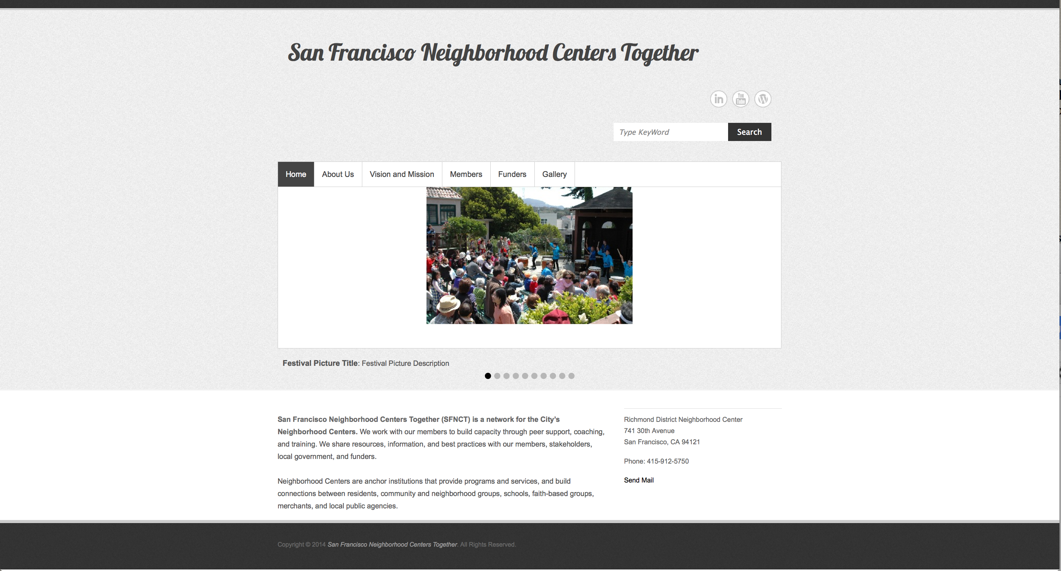

About Us

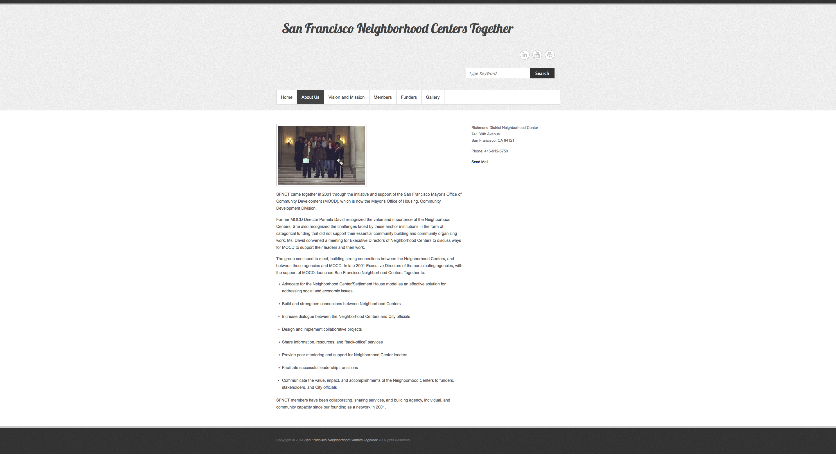

Vision and Mission

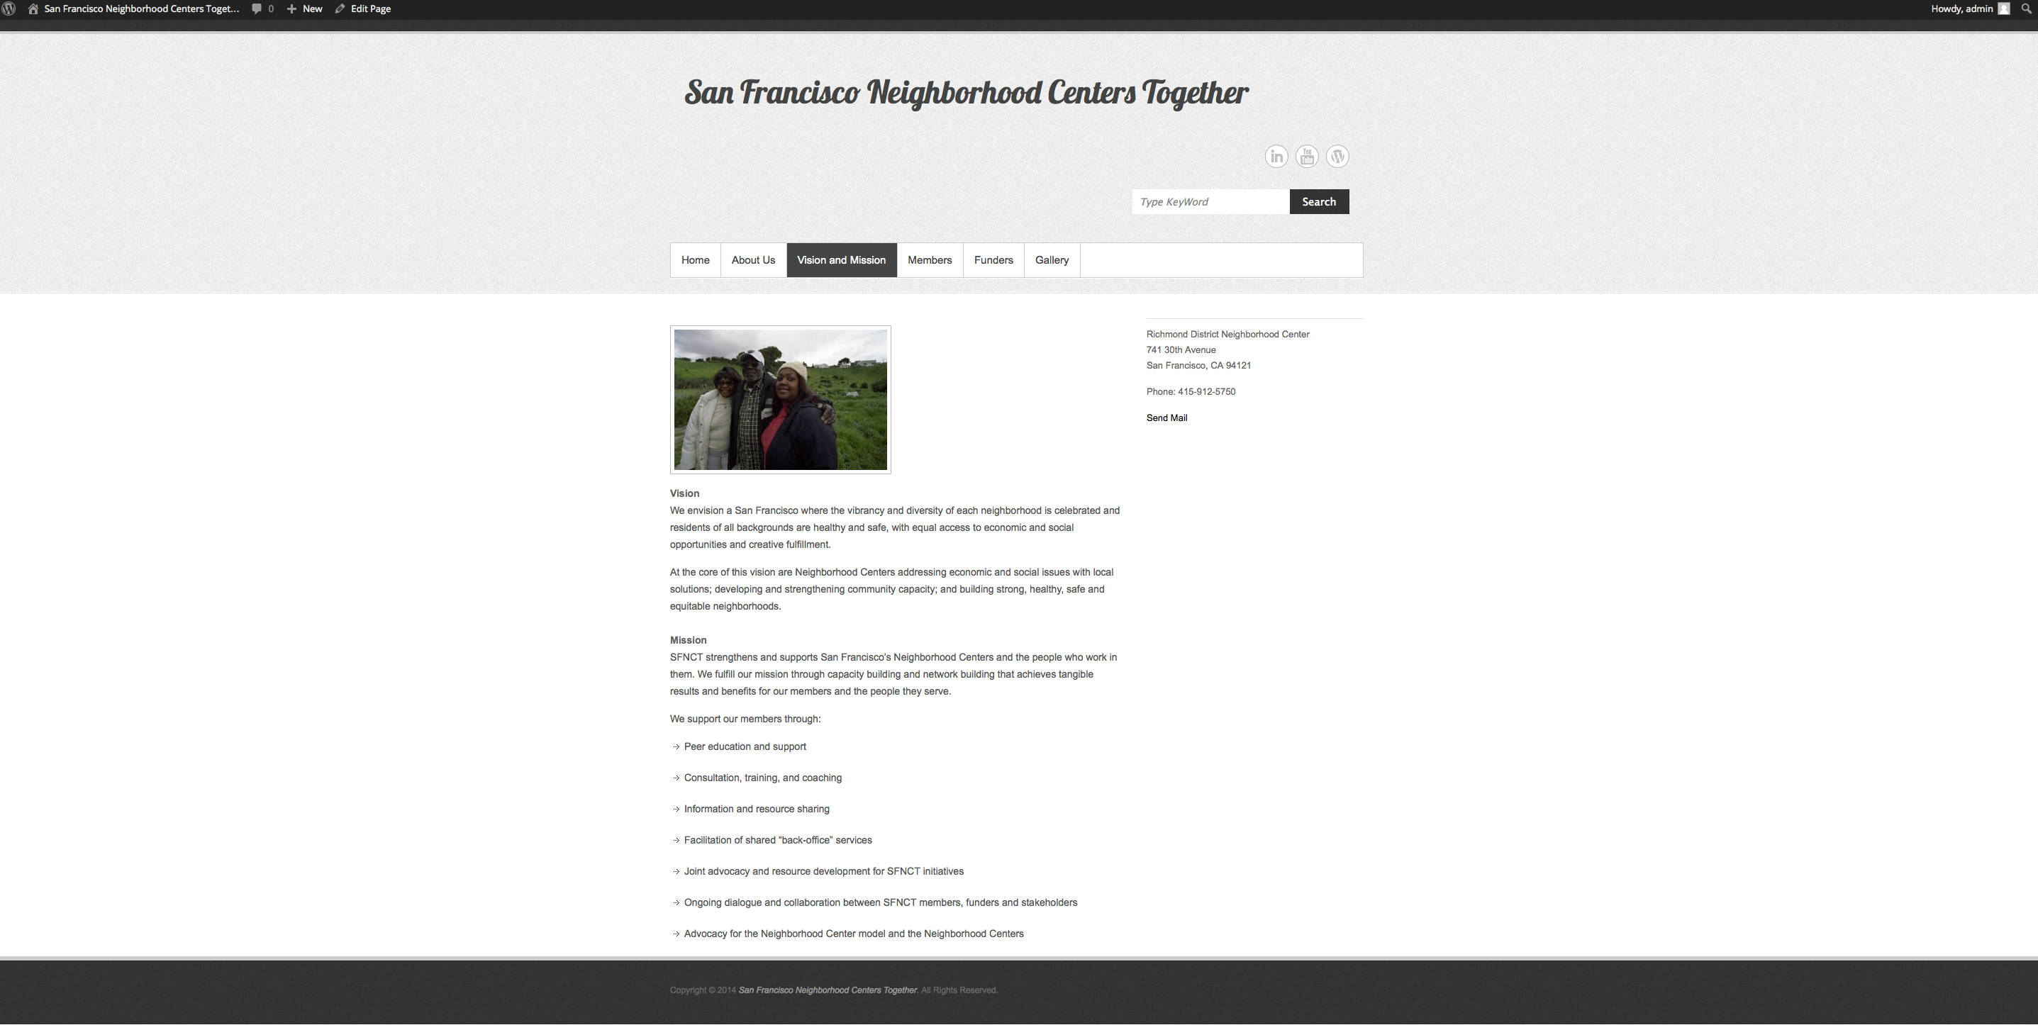

Members

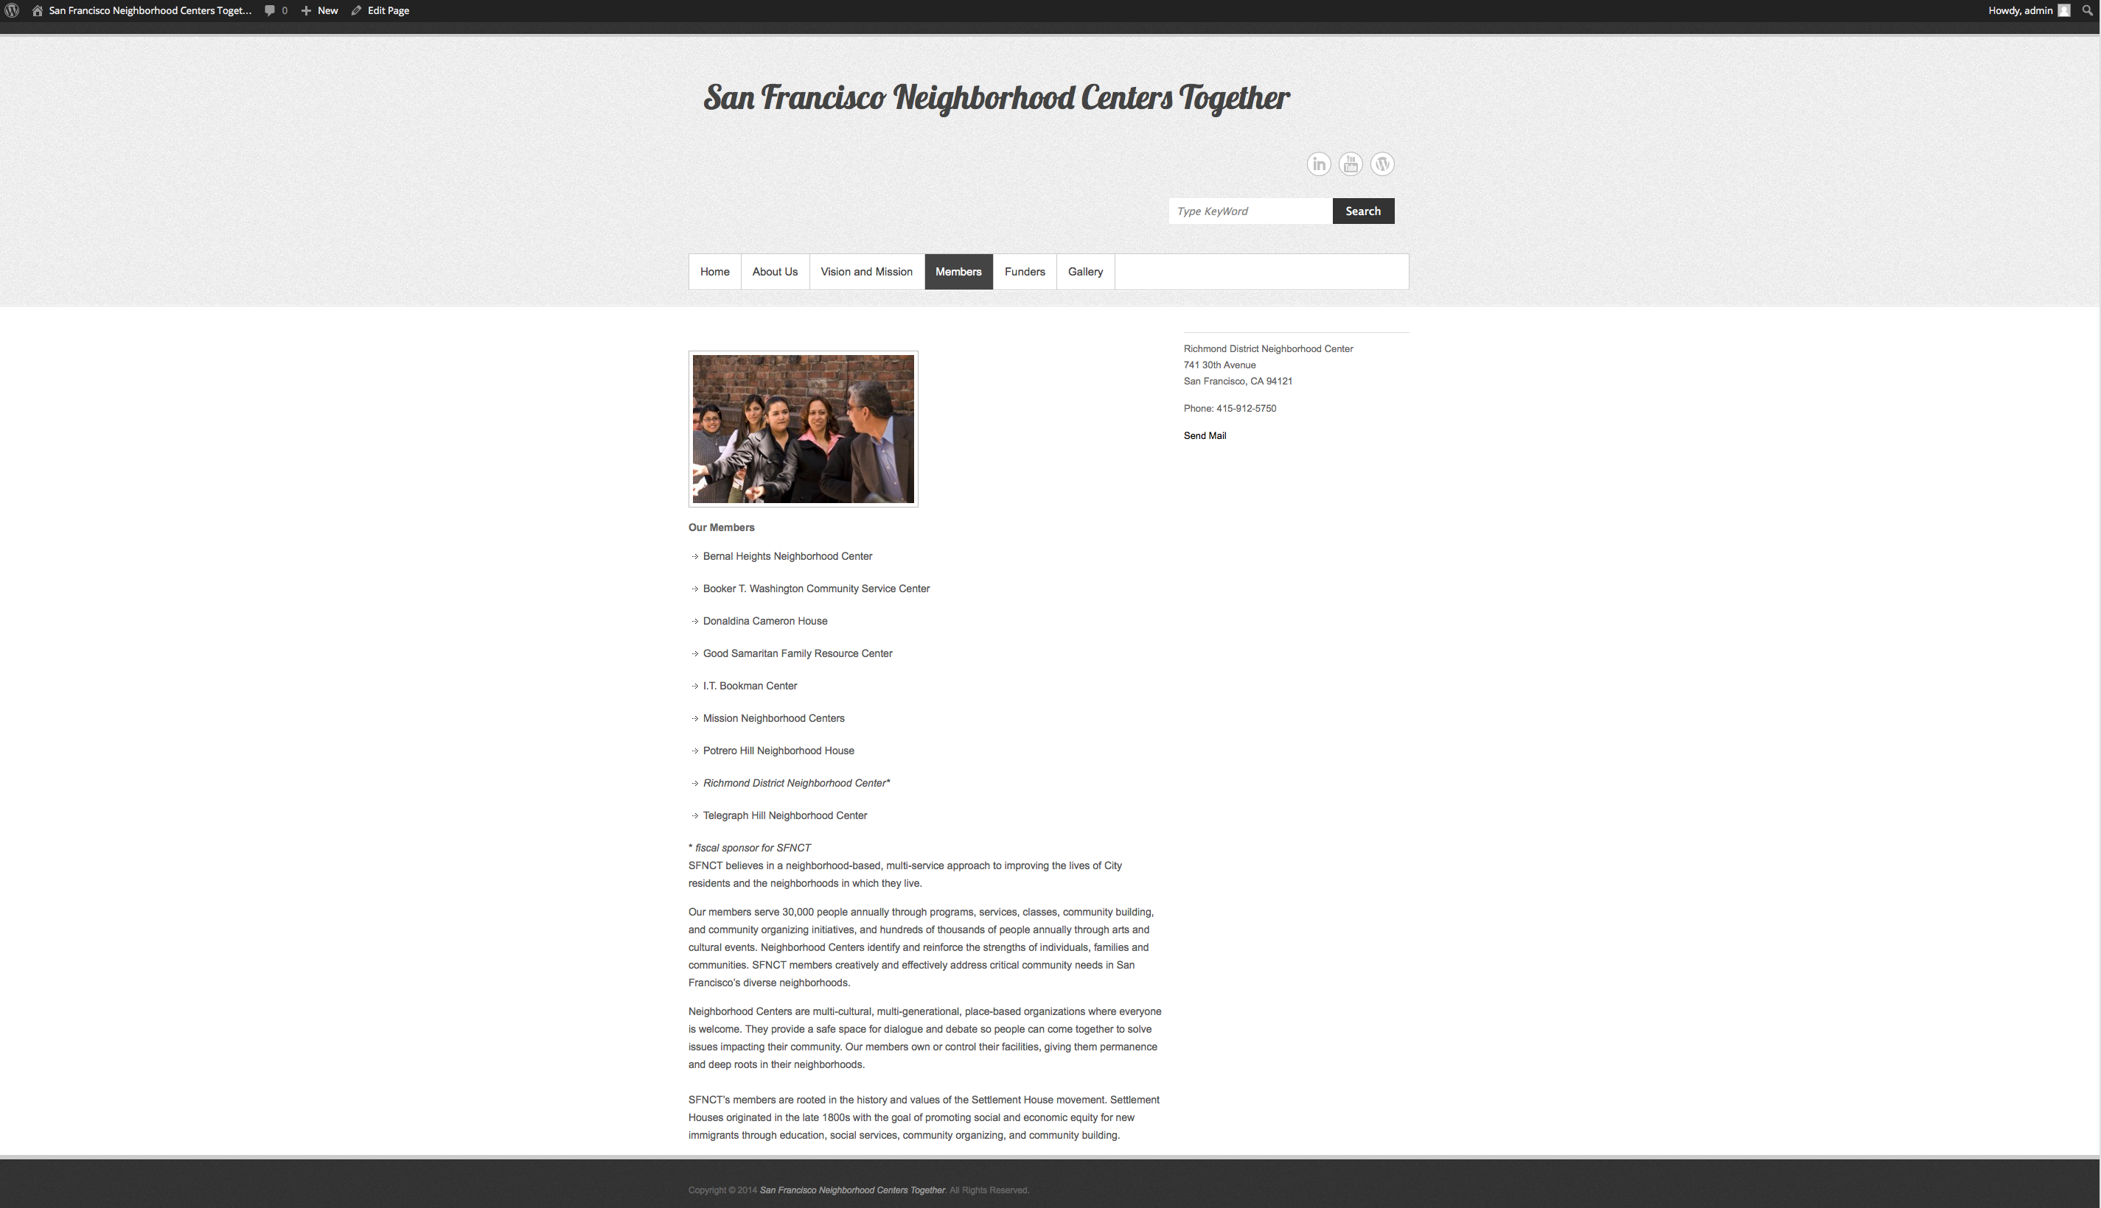

Funders

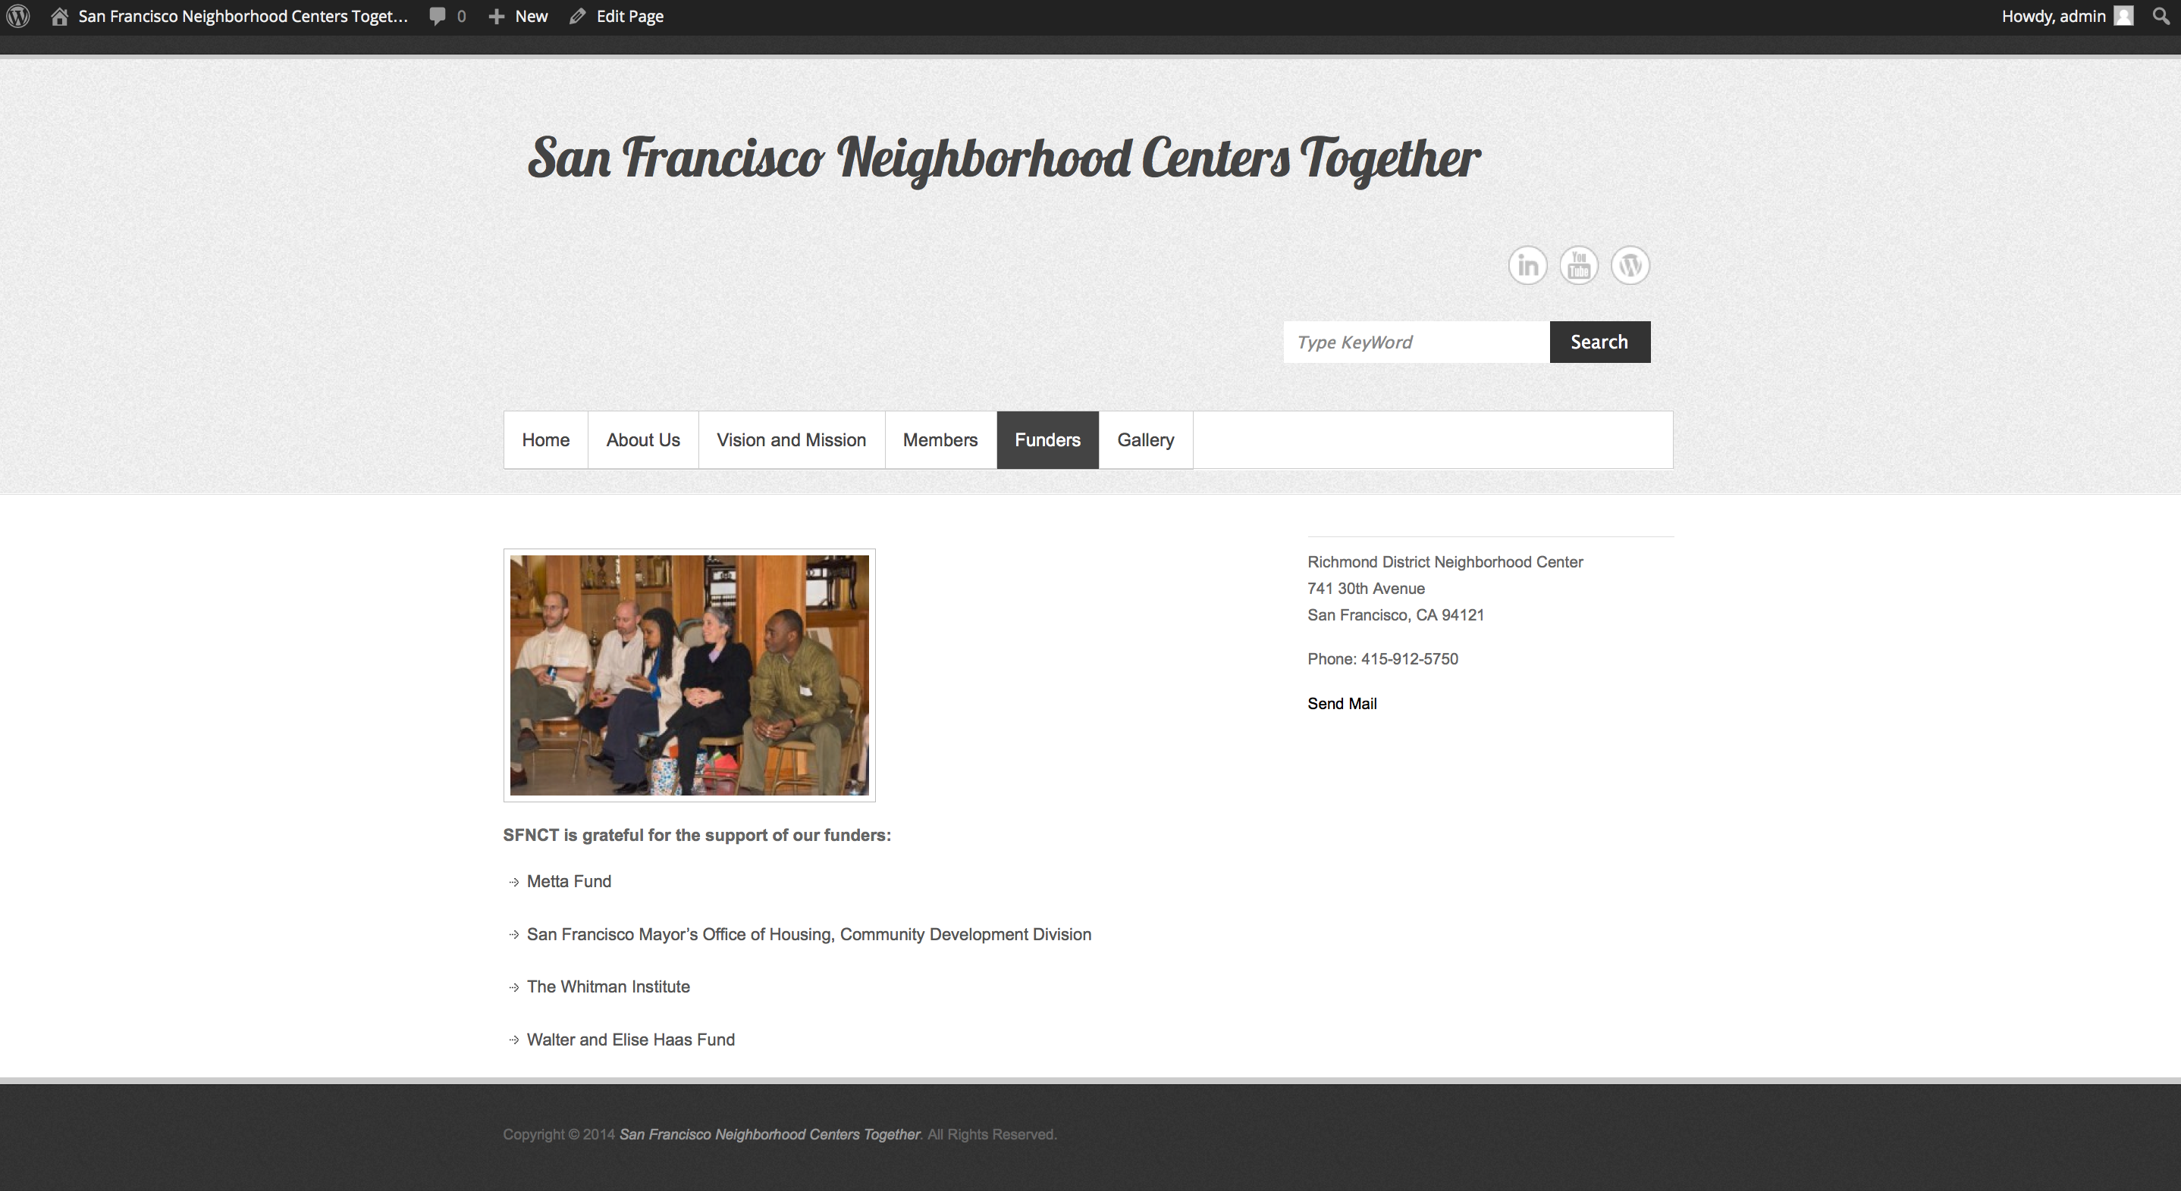

Gallery

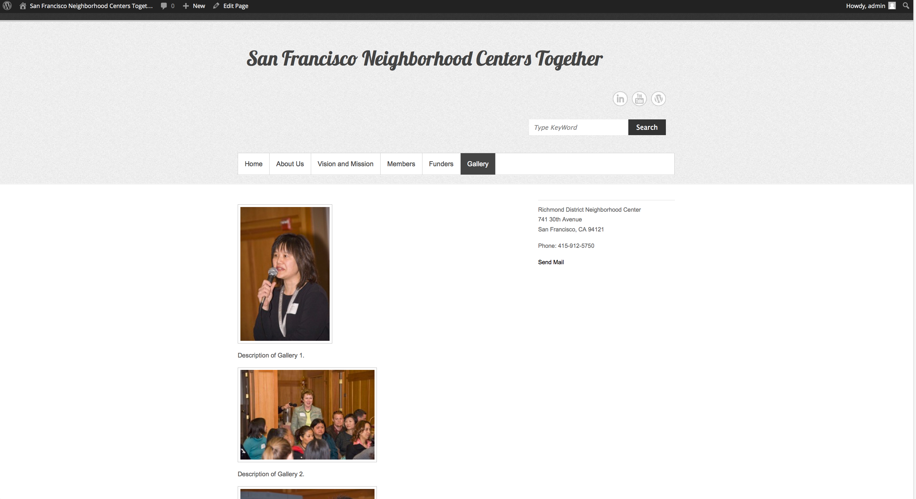

Key Word Search Tool

